Library Management System

Project Report
Author: Karan Tiwari
Date: August 2026

Table of Contents
- Project Title
- Problem Statement
- Objectives
- System Architecture
- Database Design
- Application Features
- Screenshots of the Application
- Technologies Used
- Conclusion

1. Project Title
Library Management System

2. Problem Statement
Managing a library's catalog, members, and book loans manually is error-prone, time-consuming, and inefficient. Librarians struggle to track overdue books, generate accurate reports, and manage member subscriptions. The lack of an automated system leads to lost books, delayed notifications, and a poor user experience for library members.

3. Objectives
- To automate the daily operations of a library including catalog management and circulation.
- To provide a secure, role-based system for Administrators, Librarians, and Members.
- To implement automated tracking of book loans and overdue notifications.
- To generate exportable reports for data analysis.
- To ensure data integrity, maintain an activity audit log, and provide a user-friendly interface.

4. System Architecture
The application follows a standard modern multi-tier architecture using Spring Boot.
Client (Web Browser) --> [REST API JSON] --> Controller (REST Controllers)
Controller --> [DTOs] --> Service (Service Layer)
Service --> [Entities] --> Repository (Spring Data JPA)
Repository --> [SQL] --> Database (Relational DB)
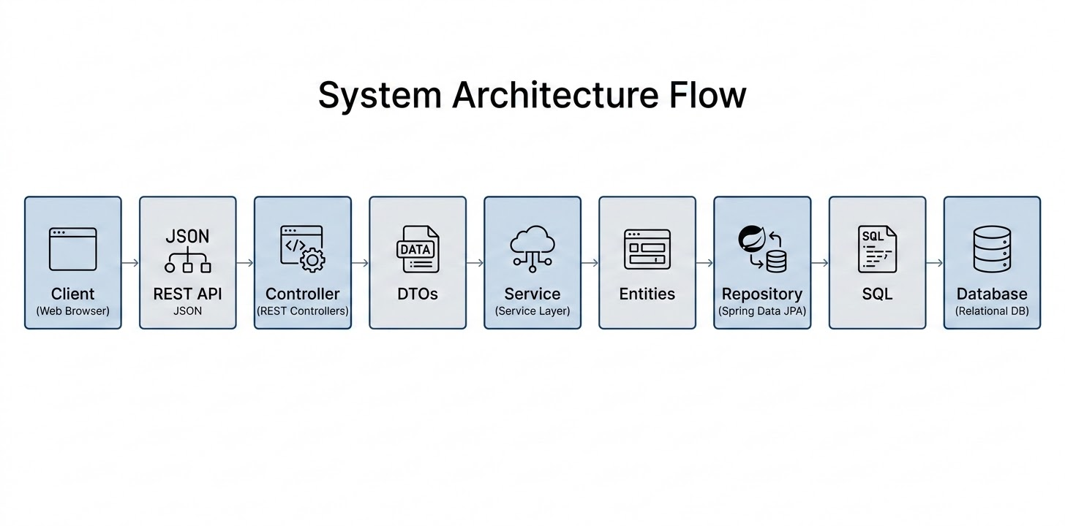
- Presentation Layer: HTML/TailwindCSS frontend interacting via REST APIs.
- Controller Layer: Spring MVC REST Controllers handling HTTP requests and input validation.
- Service Layer: Contains core business logic and transaction management.
- Data Access Layer: Spring Data JPA repositories interfacing with the database.

5. Database Design (ER Diagram)
The relational database schema is designed to ensure normalization and data integrity.
Entity | Attributes (PK highlighted)
USER | Long id (PK), String username, String password, String email, String fullName
ROLE | Long id (PK), String name
MEMBER | Long id (PK), String email, String fullName, String phone
BOOK | Long id (PK), String title, String isbn, int publicationYear
AUTHOR | Long id (PK), String name, String bio
CATEGORY | Long id (PK), String name, String description
LOAN | Long id (PK), LocalDate loanDate, LocalDate dueDate, String status
AUDIT_LOG | Long id (PK), String action, String username, LocalDateTime timestamp
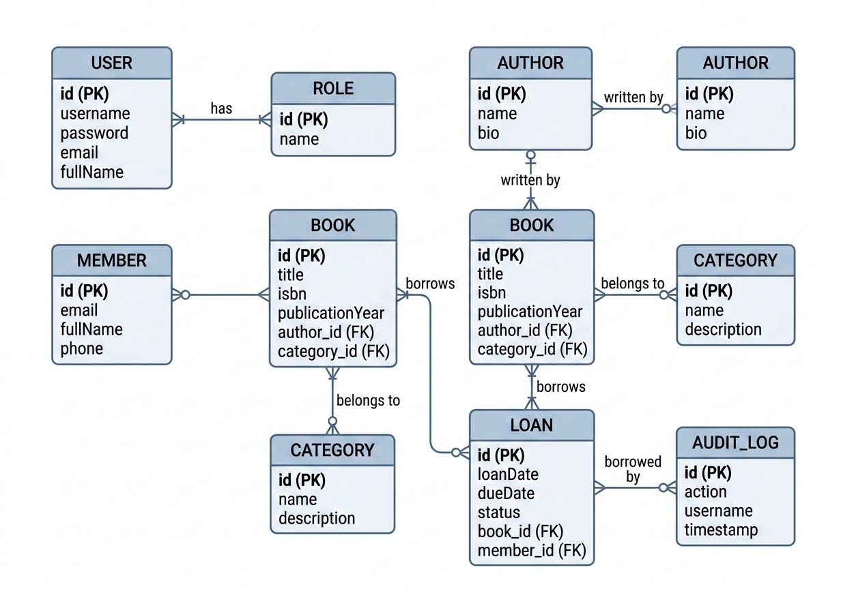

Relationships
- USER }|--|{ ROLE : "has"
- BOOK }|--|| AUTHOR : "written by"
- BOOK }|--|| CATEGORY : "belongs to"
- LOAN }|--|| BOOK : "borrows"
- LOAN }|--|| MEMBER : "borrowed by"

6. Application Features
- Complete CRUD Operations: Comprehensive management of Books, Authors, Categories, and Members.
- Authentication & Authorization: Secure JWT-based login with Role-Based Access Control (Admin, Librarian, Member).
- Loan Management & Scheduling: Tracks borrowed books and automatically marks them overdue using Spring Scheduled Tasks.
- Email Notifications: Automatically emails members when their books become overdue.
- Reporting: Export functionality for Loan data (PDF) and Book data (CSV).
- Audit Logging: Tracks system actions (e.g., adding books, changing loan status) utilizing Spring AOP.
- Advanced Search & Filtering: Uses Spring Data Specifications and Pagination for efficient catalog browsing.

7. Screenshots of the Application
Note: The Google Docs API currently does not support direct embedding of image files. Visual styled placeholders have been implemented where the images from the final PDF report should be placed.

Login Screen
The secure authentication portal for accessing the system.

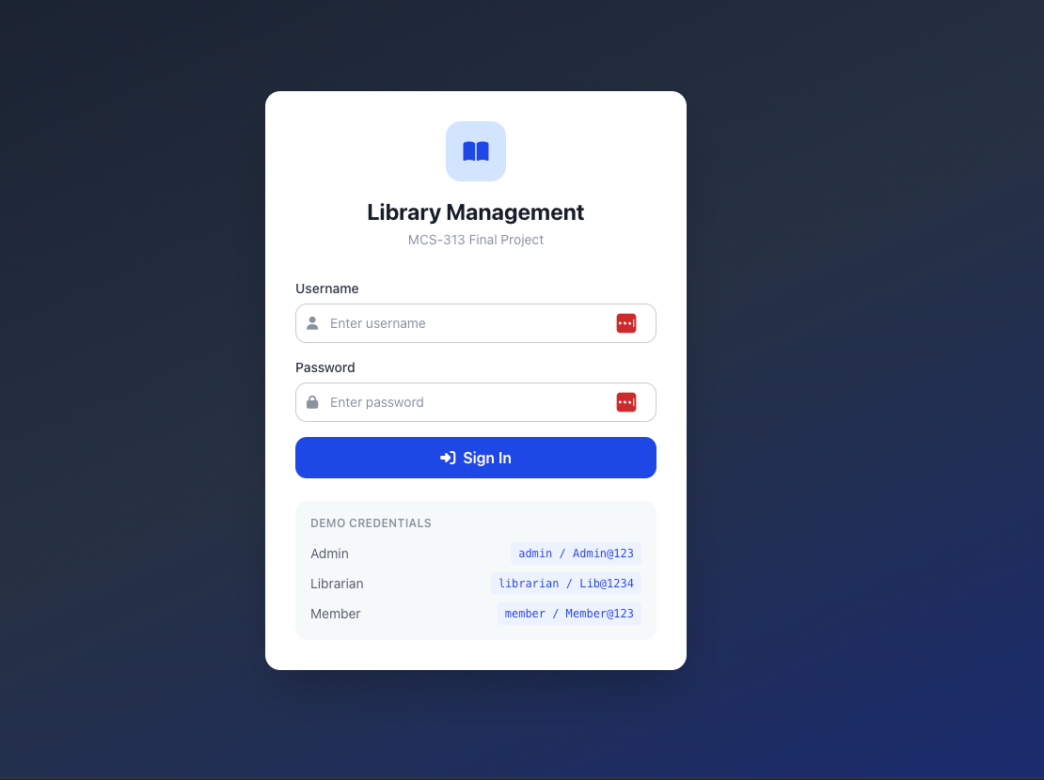

Admin Dashboard
Provides a high-level overview of system metrics, total books, and recent activity.

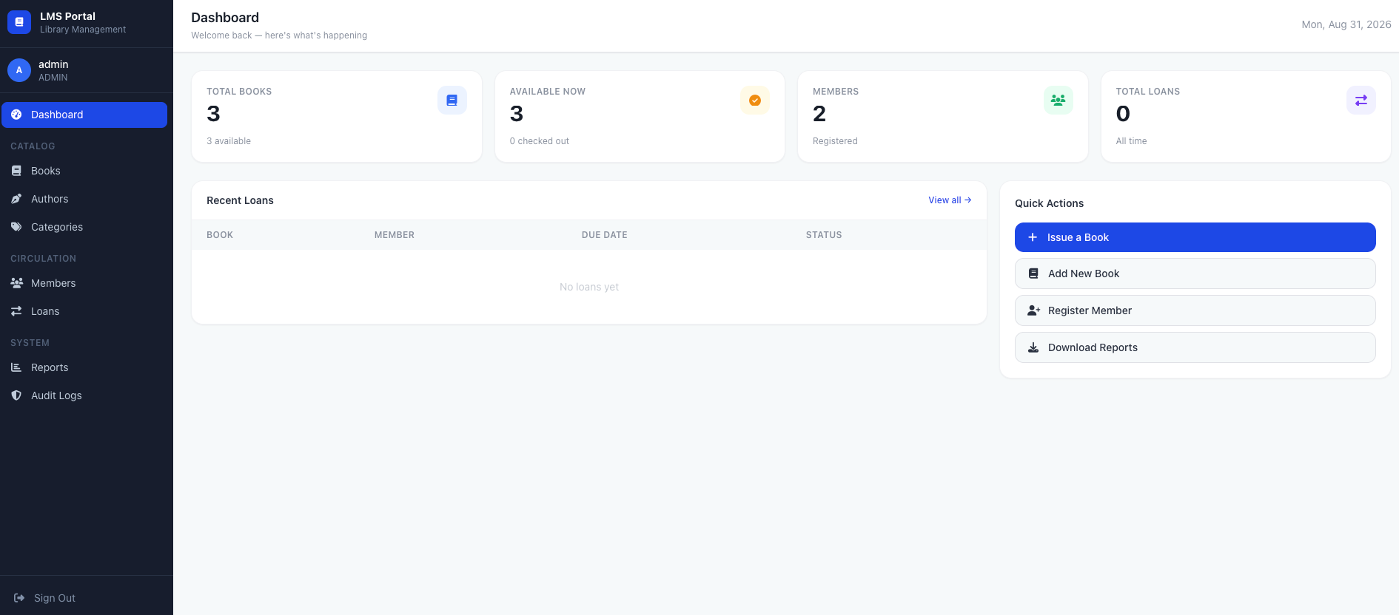

Librarian Dashboard
Dashboard tailored for librarians to manage library circulation and inventory.

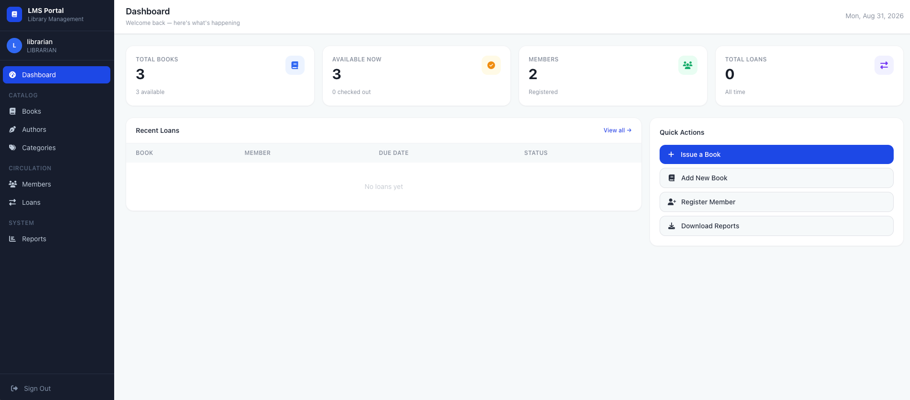

Member Dashboard
User view for browsing the catalog and tracking personal loans.

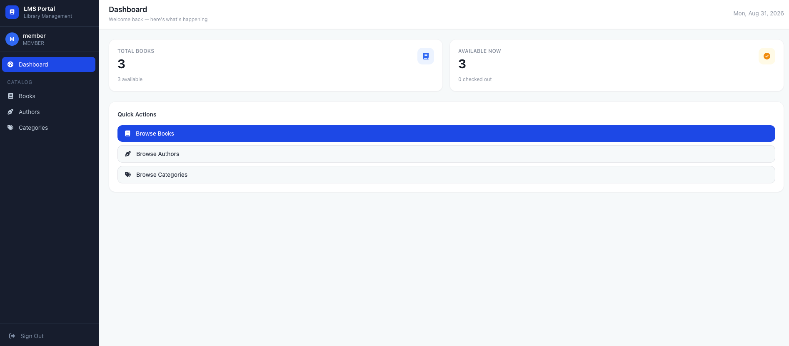

Swagger UI API Documentation
Interactive API documentation generated by Spring Doc OpenAPI.
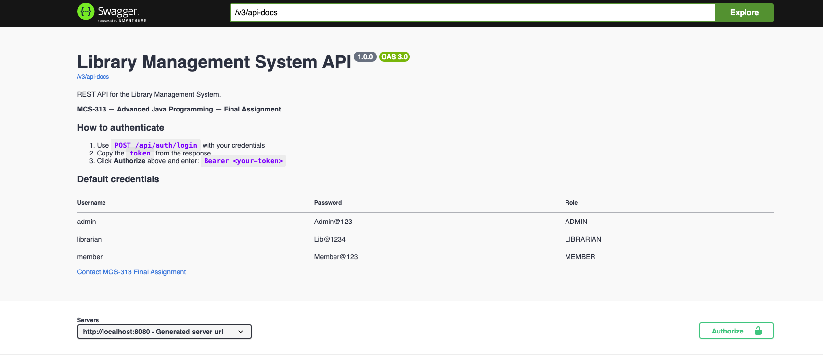

H2 Database Console
Access to the embedded H2 relational database interface.
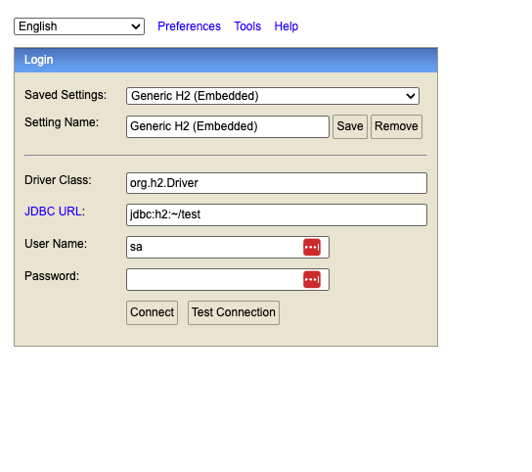

8. Technologies Used
- Backend Framework: Java 17, Spring Boot 3.x
- Data Access & Database: Spring Data JPA, Hibernate, MySQL / H2 Database
- Security: Spring Security, JSON Web Tokens (JWT)
- Frontend: HTML5, Vanilla JavaScript, TailwindCSS
- Reporting & Utilities: OpenPDF (PDF Export), OpenCSV (CSV Export), Spring Mail (Email Notifications)
- API Documentation: Spring Doc OpenAPI (Swagger UI)
- Build Tool: Apache Maven

9. Conclusion
The Library Management System successfully fulfills all objectives by providing a robust, scalable, and user-friendly application. By leveraging the advanced features of the Spring Boot ecosystem—such as Spring Data JPA for seamless database integration, Spring Security for robust protection, and Spring AOP for audit logging—the system effectively automates complex library workflows and provides an excellent foundation for future enhancements.

